PRODUCT BULLETIN
MODEL SHORT-SET CAST IRON HEAD VERTICAL TURBINE
Bulletin 480SVT
Edition 1


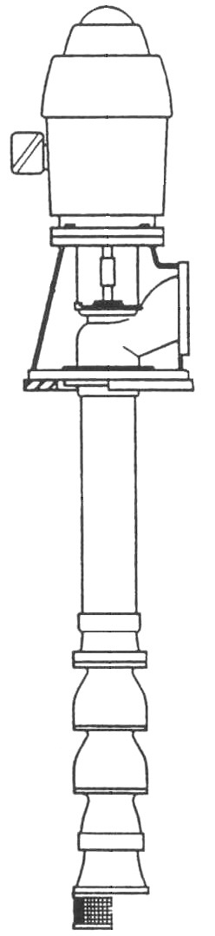
Short-Set Cast Iron Head Vertical Turbines
PRODUCT BULLETINMUNICIPALCOMMERCIALINDUSTRIAL
MODEL VERTICAL TURBINEQuench Water, Filtration, Transfer,HVAC, Booster, Supply Water,Process, Petrochemical,
Filter Backwash, CirculationCooling TowerCargo Transfer

The American-Marsh Vertical Turbine pumps are designed for long, dependable life in many applications. Modern processing methods require modern pumping equipment to satisfactorily handle the many and varied fluids used in the various industries. American-Marsh Engineers, backed by over 125 years of manufacturing experience, have met this demand with the vertical turbines offered today. We have incorporated in our design, ideas and suggestions from competent engineers from all sections of the country.

Material Specifications
PART | CONSTRUCTION
PART | BRONZE FITTED | ALL IRON | ALL BRONZE
Bowl Assembly | Cast Iron | Cast Iron | Bronze
Bowl Bearings | Bronze | Bronze | Bronze
Impeller(s) | Bronze | Cast Iron | Bronze
Bowl Shaft | 416 SS | 416 SS | 416 SS
Strainer | Galvanized Steel | Galvanized Steel | Galvanized Steel
Discharge Column | A53 Steel | A53 Steel | A53 Steel
Column Shaft | C1045 Steel | C1045 Steel | C1045 Steel
Column Bearings | Rubber | Rubber | Rubber
Discharge Head | Cast Iron | Cast Iron | Cast Iron

PUMPING CONDITIONS:

Fluid to be Pumped:
Design Capacity (USGPM):
Differential Head (FEET):
Maximum RPM:
Minimum acceptable bowl efficiency, (%):
Viscosity (SSU):
Specific Gravity:
Suction Pressure (PSIG)
Temperature (°F):
Bulletin 480SVT
Edition 1

MODEL SHORT SET CAST IRON VT SPECIFICATIONS

Bowl Assembly: The pump bowls shall be of close grained, cast iron ASTM A48 Class 30. The water passages on bowl sizes 6” through 16” shall be lined with porcelain enamel or fusion epoxy lined to reduce friction loss, shall be free of blow holes, sand holes and other detrimental defects, and shall be accurately machined and fitted. The impellers shall be of bronze (enclosed or semi-open) and dynamically balanced. Impellers through 16” shall be securly fastened to the shaft with taper split bushings of steel. Larger sizes shall be double-keyed. Impellers shall be adjusted vertically by an external means.

The pump shaft shall be of A582 grade 416 stainless steel, turned, ground and polished. It shall be supported by bronze bearings above and below each impeller. The suction case bearing shall be grease lubricated and protected by a bronze sand collar. The size of the shaft shall be no less than that determined by ANSI/AWWA Specifications E101, Section A4.3 paragraph 4.3.3.

Strainer: A __________ basket type clip-on strainer shall be provided having a net inlet area equal to at least four times the suction pipe area. The maximum opening size shall not be more than 75 percent on the minimum opening of the water passage through the bowl and impeller.

Column Assembly: The lineshafts shall be of __________. They shall be furnished in inter-changeable sections not over __________ feet in length.

The butting faces shall be machined square to the axis of the shaft, with maximum permissable axial misalignment on the thread axis with the shaft axis 0.002” in 6”. The size of the shaft shall be no less than that determined by ANSI/AWWA-E101 Specifications Section 5.5 for C1045 lineshaft and shall be such that elongation due to hydraulic thrust will not exceed the axial clearance of the impellers in the pump bowls. Maximum runout in 10’ shall not exceed 0.005”.

The lineshafts shall be provided with ASTM A269 grade 304 stainless steel threaded sleeves at the location of each lineshaft bearing. The use of glues or any other means of securing the sleeve to the shaft, that is not field replaceable without the use of heat or special tools is not acceptable. The lineshaft bearing shall be of 70 minimum shore hardness, neoprene, snap-in type, internally sprial grooved to flush out sand and other abrasives, mounted inside bronze bearing retainers held in position in the column pipe. Bearing spacing shall not exceed 10’ for 1800 RPM of 5’ for 2200 RPM and above.

The outer column pipe shall be 5” and larger of ASTM A53 grade B steel pipe of ASTM A120 in interchangable sections not over 10’ in length for 1800 RPM and 5’ in length for 2200 RPM and above.

THREADED: The ends of each section faced parallel and machined with 8 straight threads per inch permitting the end to butt and insuring alignment when connected by standard mill steel coupling.

FLANGED: The column assembly shall be flanged and machined to accept bearing retainer in such a way as not to allow any movement of retainer after flanges are bolted securely together and to implement proper sealing of the column. The weight of the column pipe shall be no less than that stated in ANSI/AWWA Specification E101, Section 5.1 “Standard Specifications for Discharge Column Pipe.” The column size shall be such that friction loss will not exceed 5’ or 100’, based on the rated capacity of the pump. If possible, the column size shall be such also be such as to provide a velocity of not less than 5 feet per second at the rated capacity.

Top and bottom sections of column pipe on product lubricated pumps shall not exceed 5’ in length.

Discharge Head: The discharge head shall be of close grain, cast iron, ASTM A48 class 30, free of sand holes and other defects, accurately machined and with a surface discharge. Discharge flange shall be machined and drilled to ANSI standards for 125 lb. rating and shall be __________ inches nominal inside diameter. The top of the discharge head shall have a rabbet fit to accurately locate the vertical hollow shaft driver, and have a diameter equal to the drive base diameter (BD) and less than __________ inches.

The standard cast iron stuffing box shall be rated for 125 PSI discharge pressure and shall be fitted with graphite acrylic packing. It shall have a lantern ring or grease chamber placed as required below the top packing ring. Throttle bearing shall be bronze with stainless steel bolting and with brass or stainless steel adjusting nuts. Sealing between the stuffing box and the discharge head shall be accomplished by means of an o-ring.

If the discharge pressure exceeds 125 PSI, a high pressure bypass style packing box shall be supplied with a minimum of six rings of packing and two lantern rings and a bypass to sump.

A unit which requires a mechanical seal shall have a housing bolted to the head with an o-ring seal. The housing shall have a lower bronze throttle bushing. The housing seal chamber shall accommodate a single sleeved (balanced/unbalanced) mechanical seal suitable for the maximum pressure developed by the pump of __________ PSI and temperature __________°F maximum. Seal materials shall be compatible with the liquid pumped. A balanced seal shall be mounted on a shaft sleeve. The shaft supplied shall be one-piece bowl, line and head-shaft where practical of 416 stainless steel material.

The top lineshaft can be of _________ and shall not exceed 10’ in length and can be equipped with a 304 stainless steel threaded replacement sleeve locked in place by a lineshaft coupling for packing wear area. Impeller adjustment shall be provided at the top of the headshaft by means of adjusting nut which shall be positively locked in position. The headshaft shall also be __________ and shall be connected to the top lineshaft beneath the motor to facilitate ease of assembly and maintenance.

Motor: The electric motor shall be vertical hollow shaft __________ RPM., three phase (50 or 60 Hz) __________ volts with a non-reverse ratchet, P-base, squirrel cage induction design. Enclosure shall meet NEMA weather protected type type 1 design with stainless steel screens to prevent entrance of rodents. Motor shall have Class B or Class F insulation with temperature rise as specified by NEMA standards for class insulation used and shall have a 1.15 service factor.

Thrust bearing shall be chosen to handle the continuous down thrust as specified by the pump manufacturer with an AFBMA B-10 one-year minimum or five year average life under design conditions. Provisions shall be made for momentary upthrust equal to 30 percent of rated down thrust. The motor rating shall be such that at design it will not be loaded beyond nameplate rating and at no place on the pump curve shall the loading exceed the service factor.

Bulletin 480SVT
Edition 1

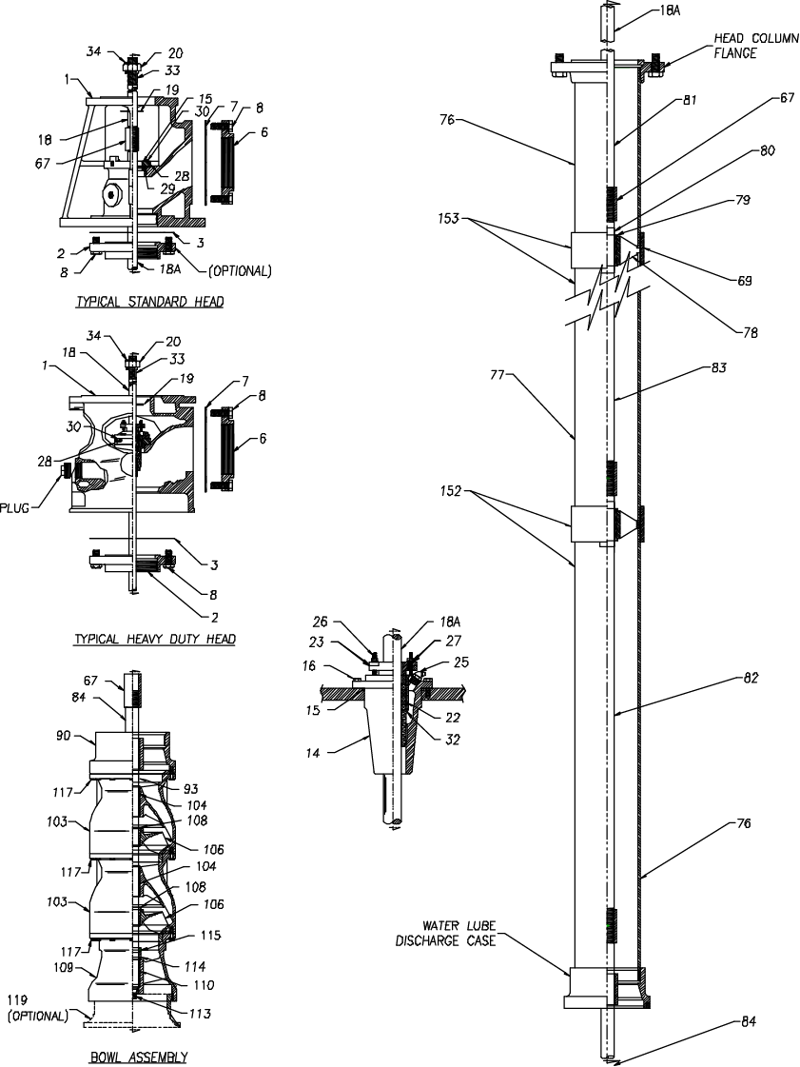
OPEN LINESHAFT TURBINE PUMP SECTIONALS
Bulletin 480SVT
Edition 1

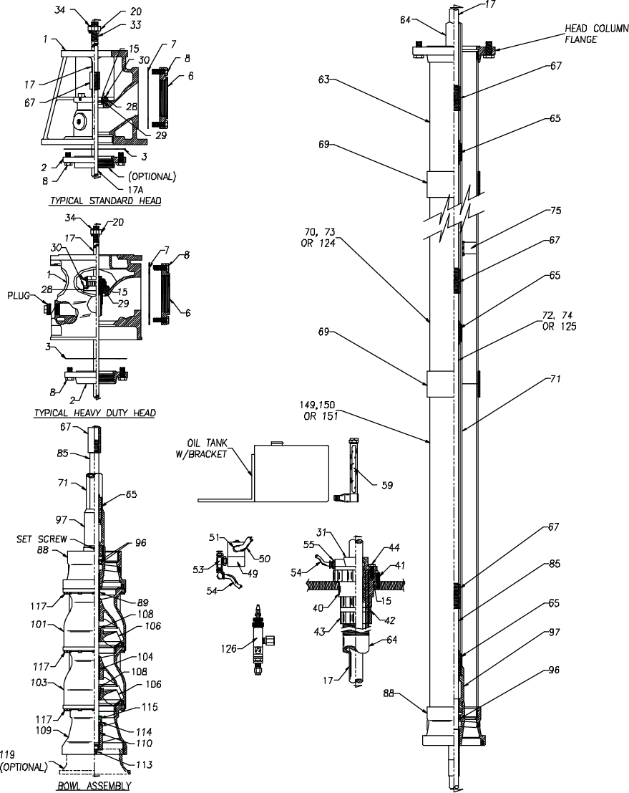
ENCLOSED LINESHAFT TURBINE PUMP SECTIONALS
Bulletin 480SVT
Edition 1

Short Set Vertical Turbine Sectional Drawing

Item Number | Item Description |  | Item Number | Item Description
1 | Discharge Head |  | 70 | Oil Lubricated O/C Section (10’ 0” long) TBE
2 | Head Column Flange |  | 71 | I/C Section (5’ 0” long)
3 | Head Column Flange Gasket |  | 72 | Oil Lubricated L/S Section (10’ 0” long)
4 | Studs |  | 73 | Oil Lubricated O/C Section (5’ 0” long) TBE
5 | Nuts |  | 74 | Oil Lubricated L/S Section (5’ 0” long) TBE
6 | Head Discharge Flange |  | 75 | I/C Stabilizing Spider
7 | Head Discharge Flange Gasket |  | 76 | Water Lubricated O/C Section
8 | Discharge Flange Assembly Cap Screws |  | 77 | Water Lubricated O/C Section
9 | Discharge Flange Assembly Nuts |  | 78 | Water Lubricated L/S Bearing Spider
10 | Head Discharge Flange Assembly Studs |  | 79 | Water Lubricated L/S Bearing
11 | Head Discharge Flange Assembly Nuts |  | 80 | Water Lubricated L/S Sleeve
14 | Head Packing Housing with Bearing |  | 81 | Water Lubricated L/S Extension (3’ 9-7/8” long)
15 | O-Ring |  | 82 | Water Lubricated L/S Section (5’ 0” long)
16 | Head Packing Housing Cap Screws |  | 83 | Water Lubricated L/S Section (10’ 0” long)
17 | Oil Lubricated Headshaft |  | 84 | Water Lubricated Bowl Shaft
18 | Water Lubricated Headshaft |  | 85 | Oil Lubricated Bowl Shaft
18A | Top Shaft |  | 88 | Oil Lubricated Discharge Case
19 | Headshaft Flinger |  | 89 | Oil Lubricated Discharge Case Bearing
20 | Headshaft Adjusting Nut |  | 90 | Water Lubricated Case Bearing
22 | Packing (Set) |  | 91 | Water Lubricated Case Bearing
23 | Packing Follower |  | 93 | Water Lubricated Case Bearing
25 | Head Packing Housing Grease Fittings |  | 94 | Sand Cap Set Screws
26 | Packing Follower Studs |  | 96 | Shaft Seal
27 | Packing Follower Retainer Nuts |  | 97 | I/C Adapter Coupling
28 | Adapter Flange |  | 101 | Top Bowl Assembly
29 | Adapter Flange O-Ring |  | 102 | Top Bowl Bearing
30 | Adapter Flange Assembly Cap Screws |  | 103 | Bowl Assembly (Enclosed Type)
31 | Oil Lubricated Headshaft Bearing |  | 104 | Bowl Bearing
32 | Water Lubricated Headshaft Bearing |  | 105 | Bowl Assembly (Semi-Open Type)
33 | Water Lubricated Headshaft Bearing |  | 106 | Impeller (Enclosed Type)
34 | Adjusting Nut Machine Screw |  | 107 | Impeller (Semi-Open Type)
40 | I/C Tension Nut |  | 108 | Taper Lock
41 | Tension Nut Set Screw |  | 109 | Suction Case Assembly (Enclosed Type)
42 | I/C Seal Ring |  | 110 | Suction Case Bearing
43 | I/C Seal Ring Nut |  | 111 | Suction Case Assembly
44 | Headshaft Bearing Assembly Cap Screws |  | 113 | Suction Case End Plug
45 | Headshaft Bearing Dust Seal |  | 114 | Suction Case Sand Cap
49 | Solenoids Valve |  | 115 | Optional Set Screws for Brass Sand Cap
53 | Vented Sight Drip Valve |  | 116 | Bowl Suction Flange
54 | Tubing for Oil Lubrication |  | 117 | Bowl Assembly Cap Screws
55 | Oil Line Connector for Headshaft Bearing |  | 119 | Suction Bell (Optional)
59 | Oil Level Sight Glass |  | 124 | Oil Lubricated O/C Section (20’ 0” long)
63 | 2’ Long O/C Adapter Nipple TBE Top Section |  | 125 | Oil Lubricated L/S Section (20’ 0” long)
64 | Inner Column Adapter 2’ 4” Long Stretch Nipple |  | 126 | Vented Toggle Valve
65 | Oil Lubricated Lineshaft Bearing |  | 149 | Oil Lubricated O/C Assembly T&C (10’ 0” long)
66 | Oil Lubricated Lineshaft Adapter Bearing |  | 150 | Oil Lubricated O/C Assembly T&C (5’ 0” long)
67 | Shaft Coupling |  | 151 | Oil Lubricated O/C Assembly T&C (20’ 0” long)
68 | Shaft Adapter Coupling |  | 152 | Water Lubricated O/C Asmbly T&C (10’ 0” long)
69 | O/C Coupling |  | 153 | Water Lubricated O/C Asmbly T&C (5’ 0” long)
Recommended spare parts are in BOLD.
Sales & Marketing: 185 Progress Road • Collierville, Tennessee • 38017
Manufacturing: 185 Progress Road • Collierville, Tennessee • 38017
Phone: (800) 888-7167
Fax: (901) 860-2323

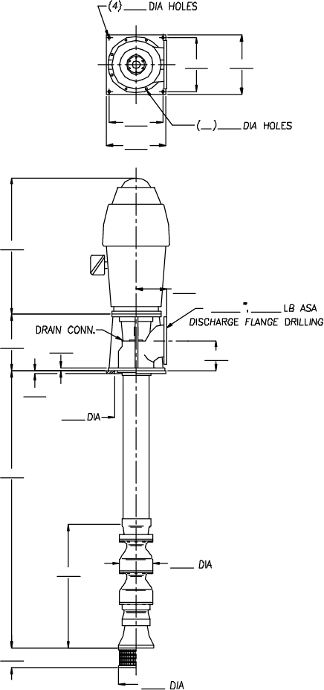
SHORT SET CAST IRON HEAD VERTICAL TURBINE
- Your Local Authorized Distributor -

Pumps...and Pumps Only...Since 1873
Bulletin 480SVT
Edition 1

MATERIALS OF CONSTRUCTION
BOWL | IMPELLER
BOWL SHAFT | SHAFT COUPLING
BOWL BEARINGS | SHAFT BEARINGS
STRAINER | BOWL W/R
IMPELLER W/R | COLUMN PIPE
LINESHAFT | PACKING
BASE PLATE | DISCHARGE HEAD

PUMP
TYPE | DISCHARGE HEAD
SUCTION | DISCHARGE
LINESHAFT | COLUMN
LUBRICATION | MODEL
STAGE | GPM
TDH | TRIM
RPM | BHP

MOTOR
MAKE | TYPE
ENCLOSURE | NRR
SRC | HP
RPM | PHASE
HERTZ | VOLTAGE
FRAME NO. | TYPE COUPLING

OTHER SPECIFICATIONS
DRAWING NO. | SERIAL NO.
FLUID | SPECIFIC GRAVITY
VISCOSITY | TEMPERATURE
PH | NO. UNITS REQUIRED
CUSTOMER
ADDRESS
CITY | ST | ZIP
TEL. ( ) | FAX. ( )
REP.
SUPPLIER
SALESMAN

